**Introduction to Tidyverse**

library (gplyr, gapminder, ggplot)

filter (year == 1987, country == "China")

arrange (Age) or arrange (desc(Age)) //sorts of ascending or descending order

% > % takes ourput from first command and gives it to the second

mutate (gdp = gdpPercap * pop) //manipulate existing dataframes, create new colums

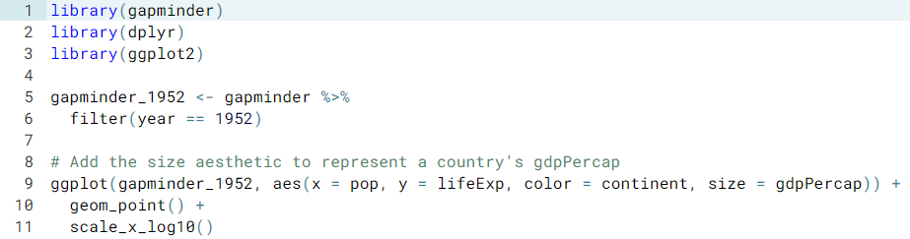

+ expand_limits(y = 0) // y graph starts at 0

facet_wrap(~ continent) // divides data on sub

summarize( meanLifeExp = mean(lifeExp), totalPop = sum(pop)) //mean – average

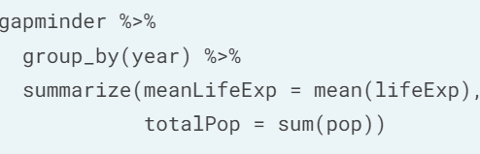//median – point in a set of numbers, half are above and half below

group_by(year, age) %>% //tells to do within each specified

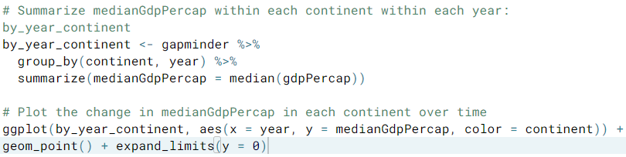

 geom_col, geom_histogram, geom_line,

<https://ggplot2.tidyverse.org/reference/labs.html> - title and etc ,.

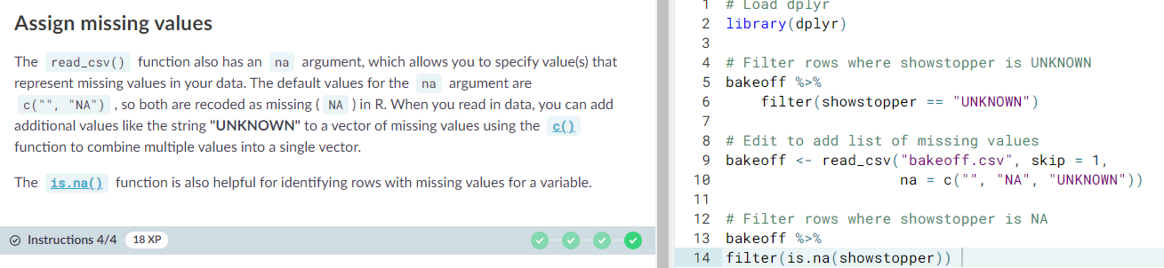**Working with Data in Tidyverse**

Glimpse () – show information in rows instead of columns

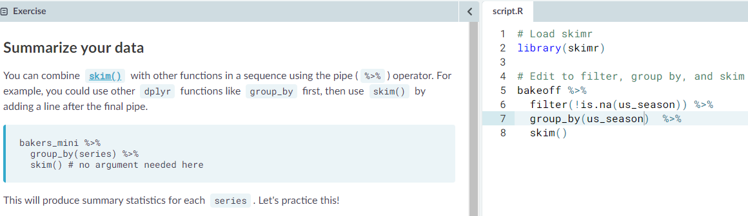Bakeoff %>% Distinct (series)

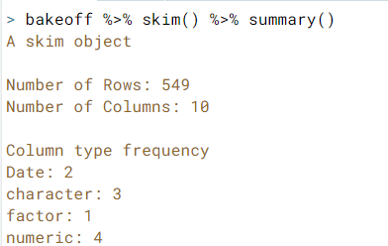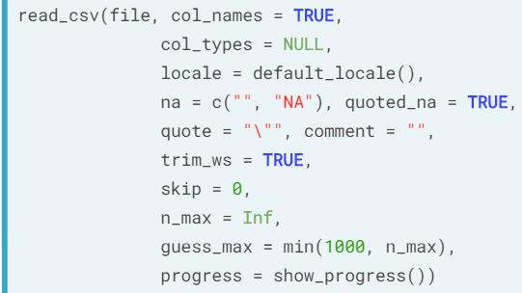Count(object) – adds new column to count / parse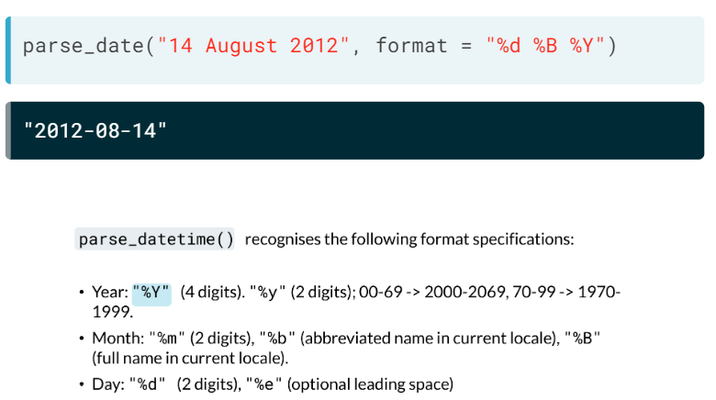

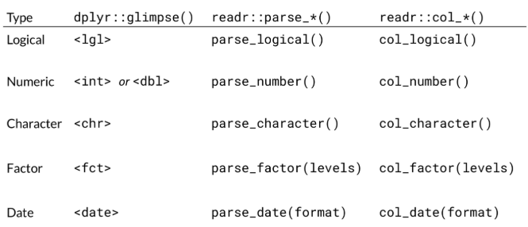

Cast?? Col?

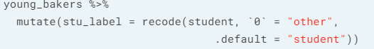

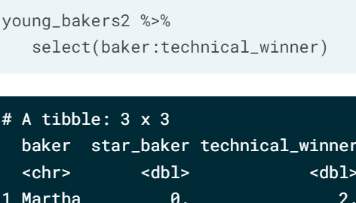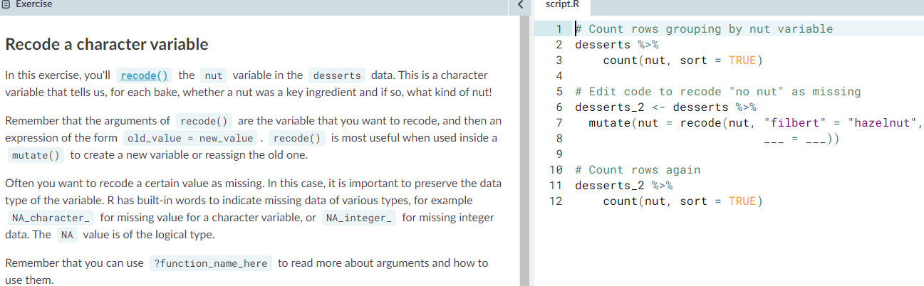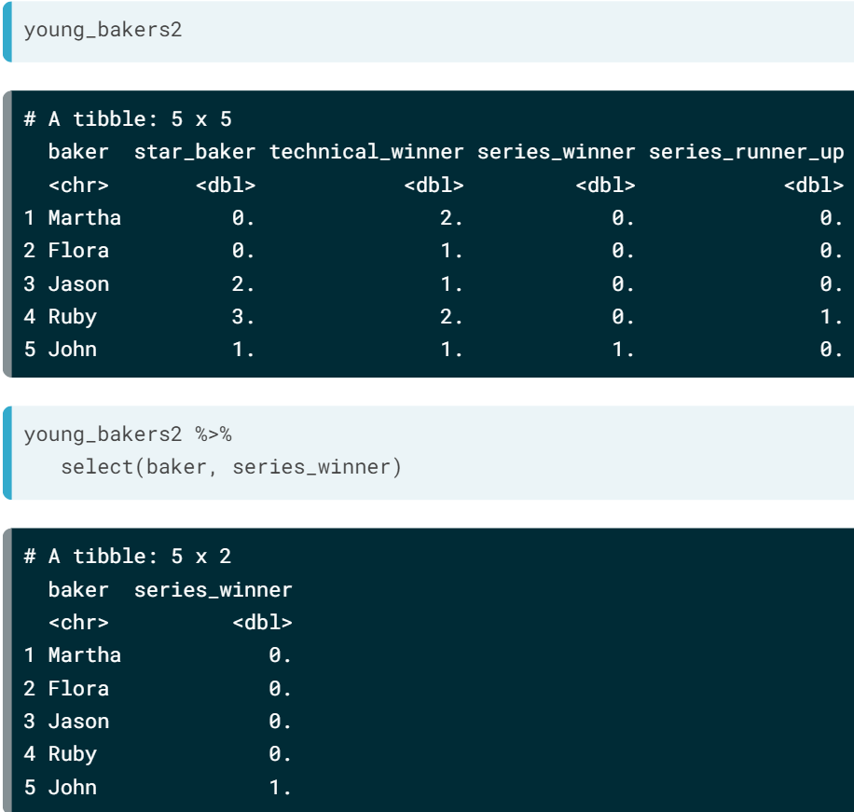 select(-object) shows all except the –

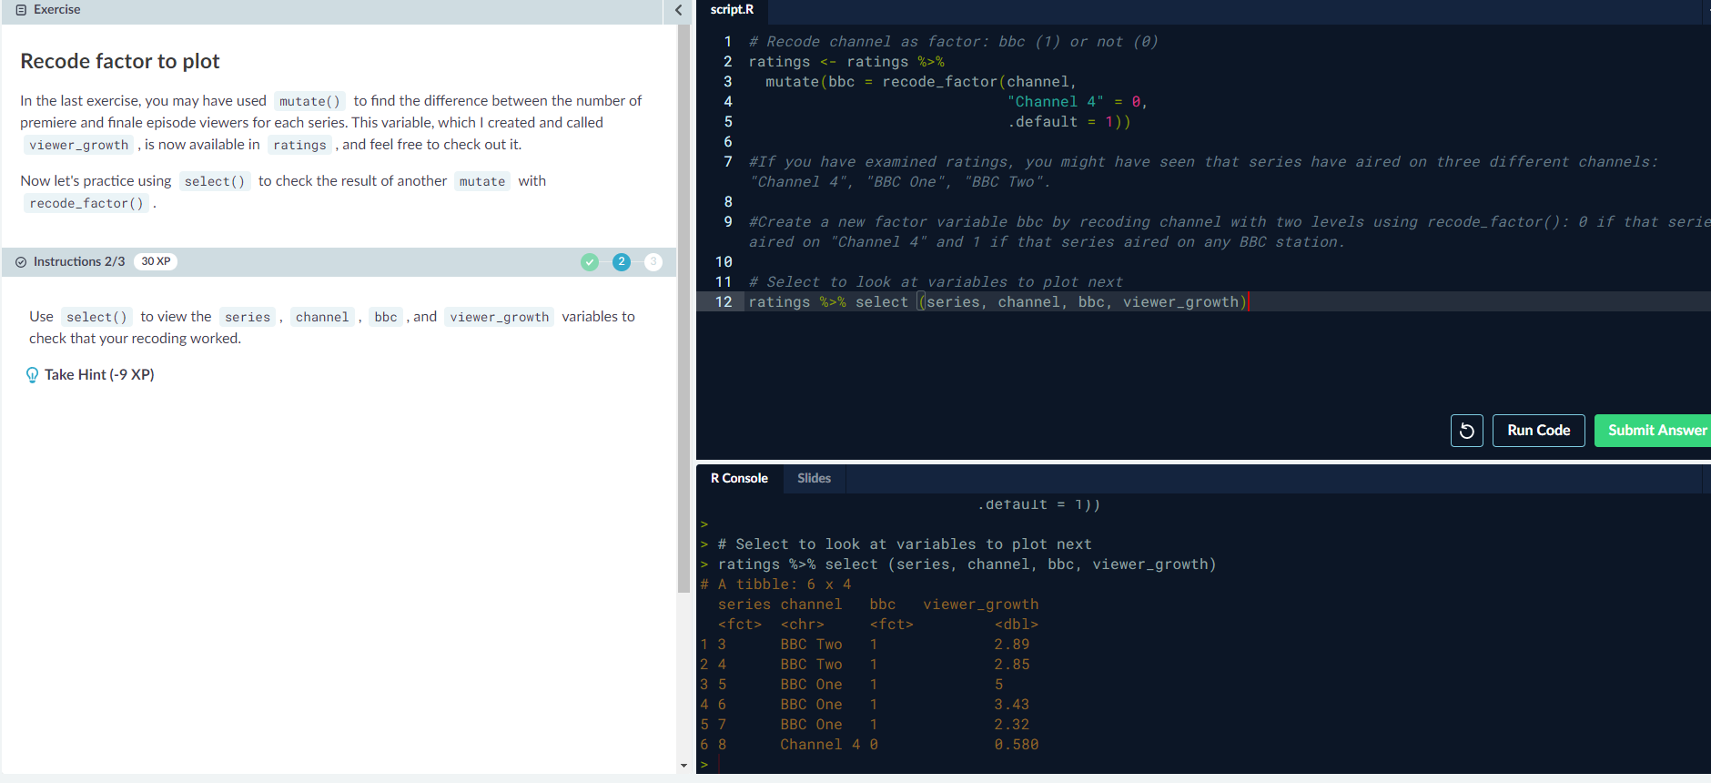Select(baker, starts_with(“series”)) // ends_with() //contains()

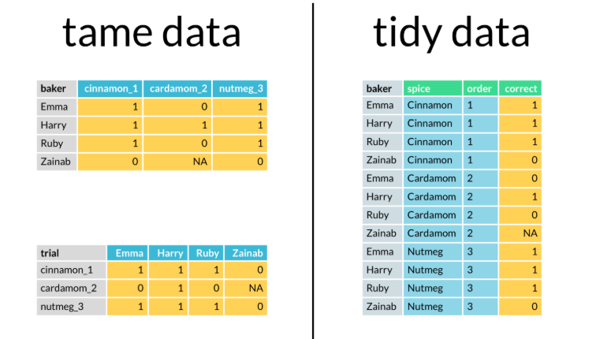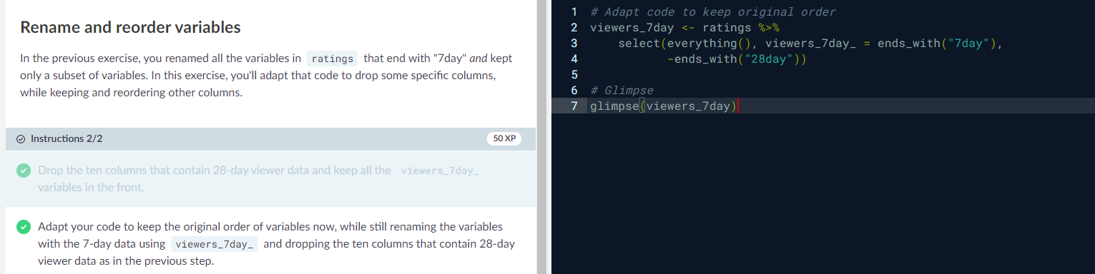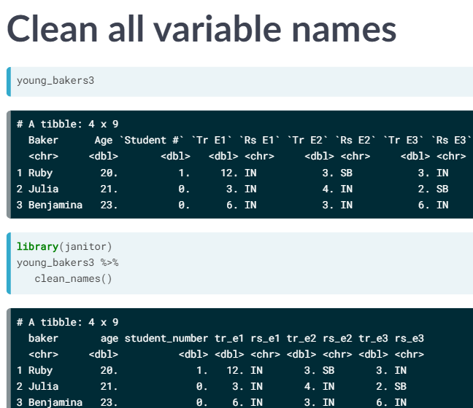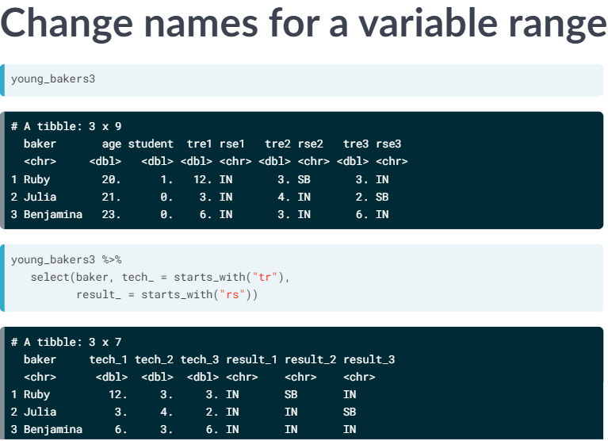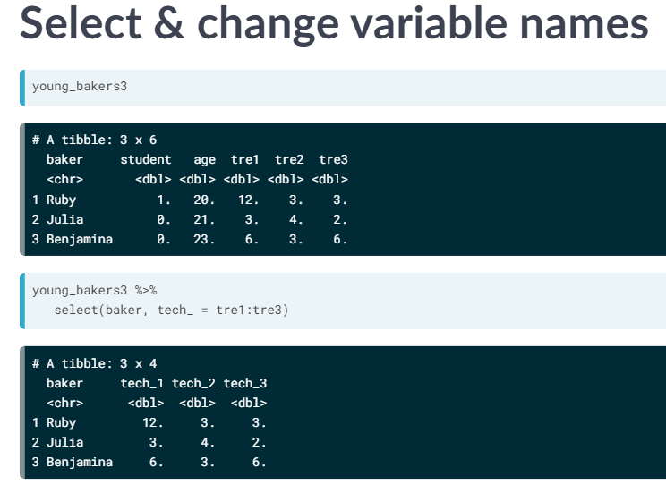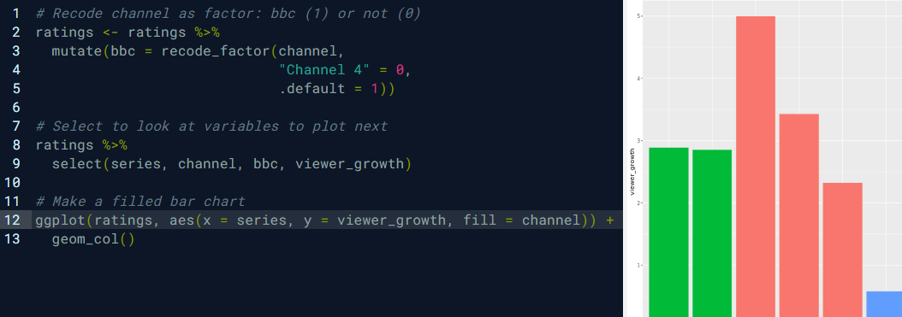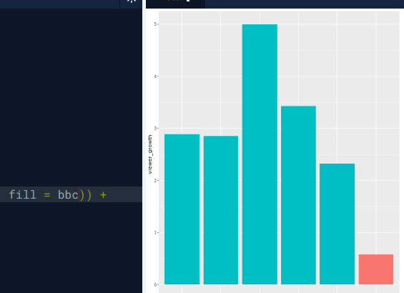  
rename(tech_1 = t_first)



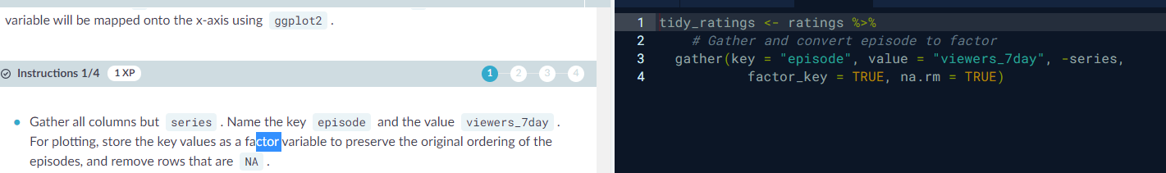gather()

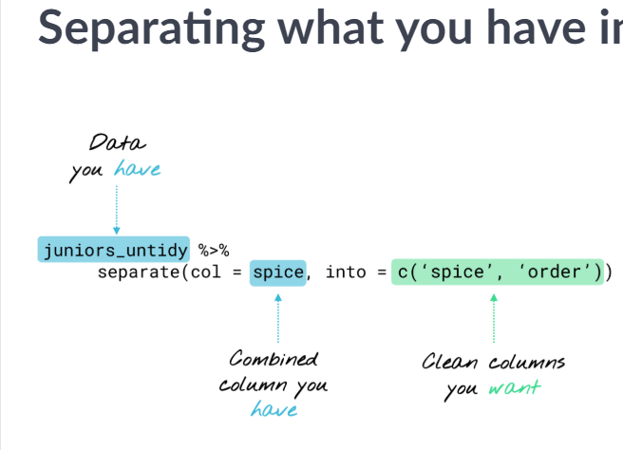

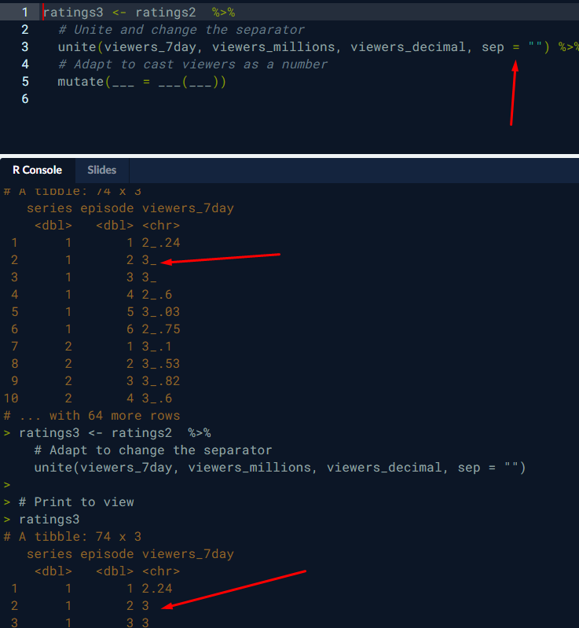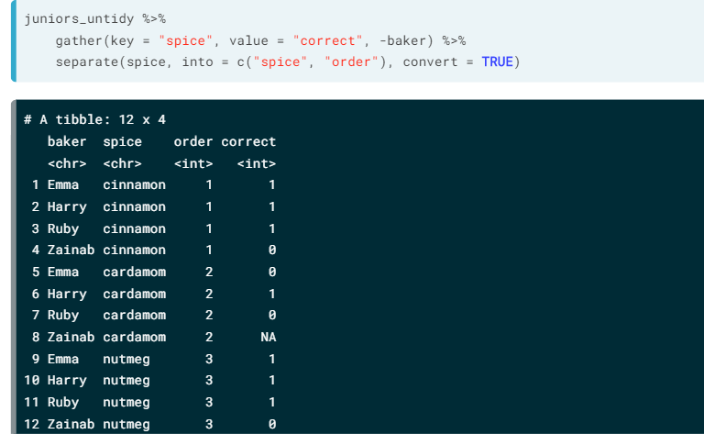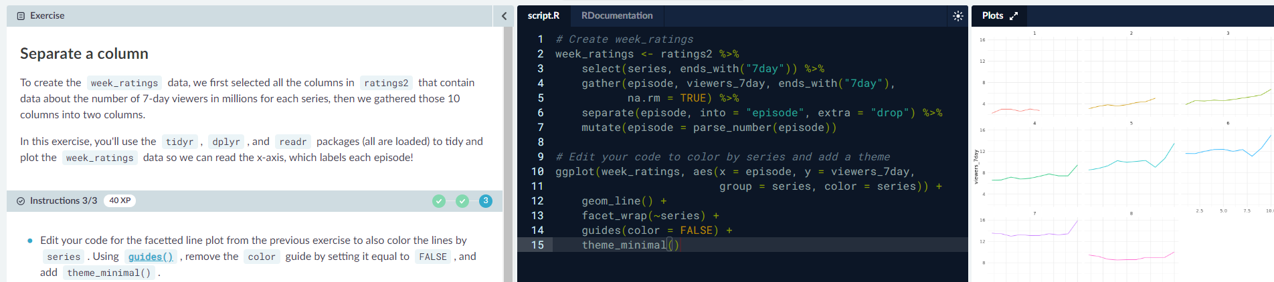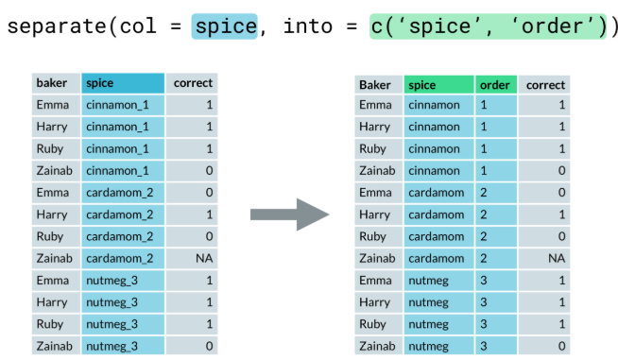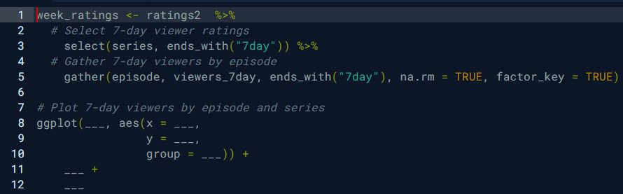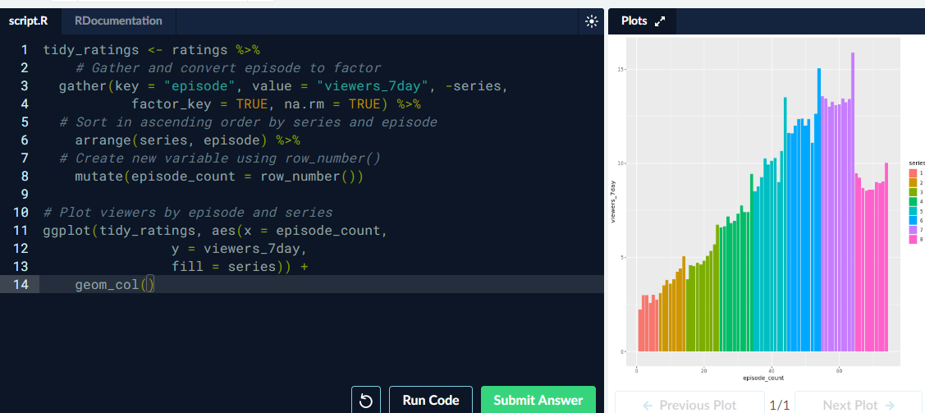Row_number / separate/ guide /

Unite / sep

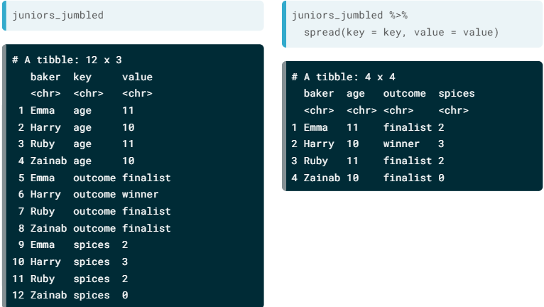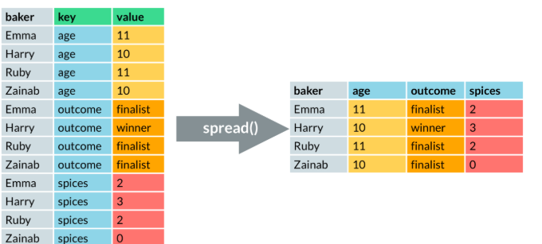Opposide of Gather is Spread

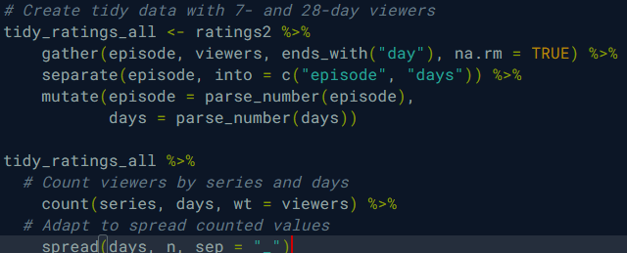REMEMBER TO USE CONVERT INT -> NUM

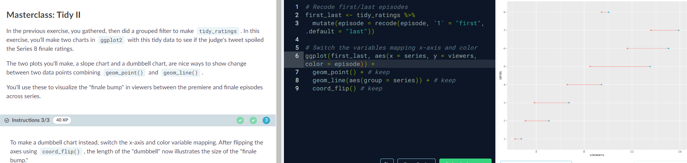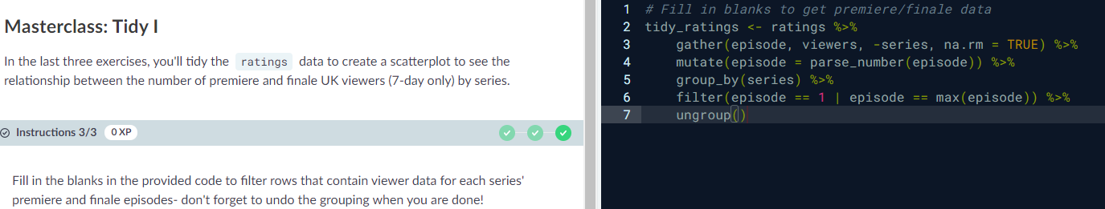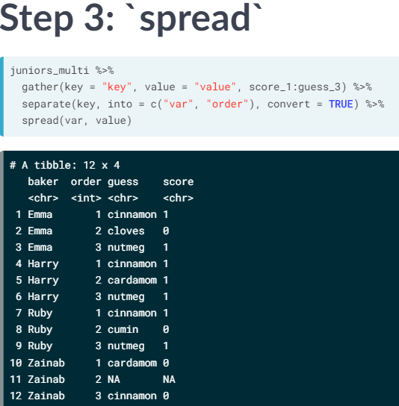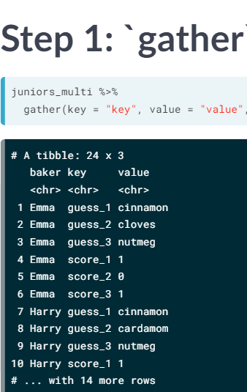

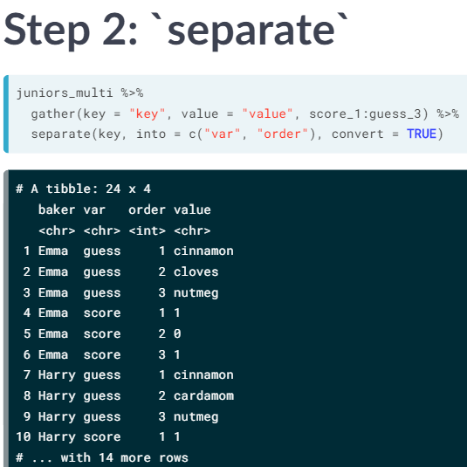

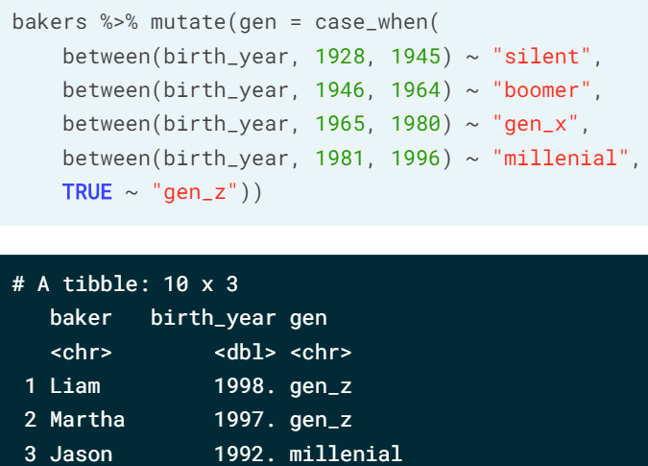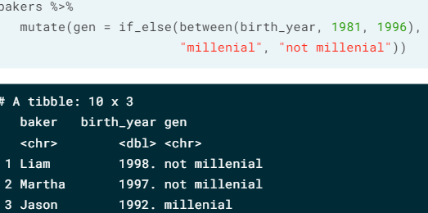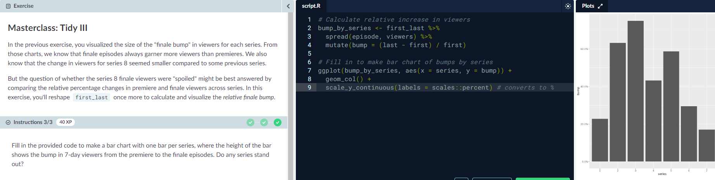if else – case_when

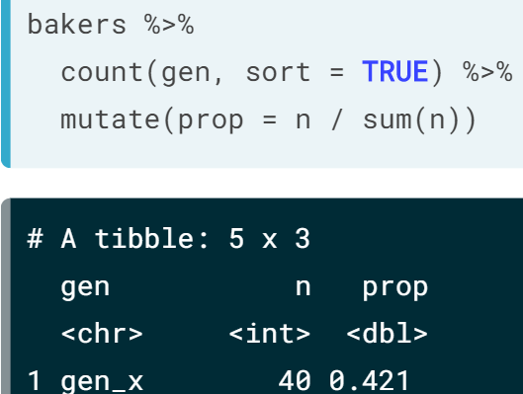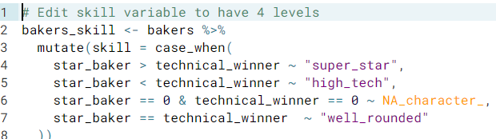TRUE ~ “gen_z” everything that is not in the mentioned ranges

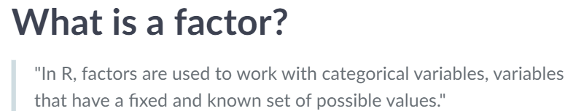Factor

Levels only works with factor variables

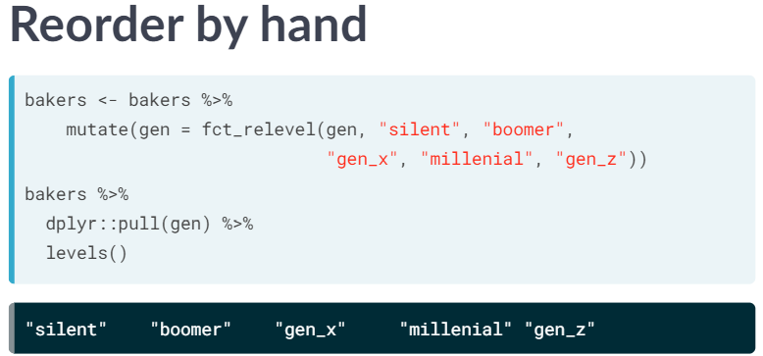

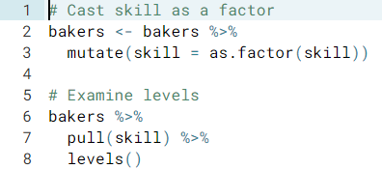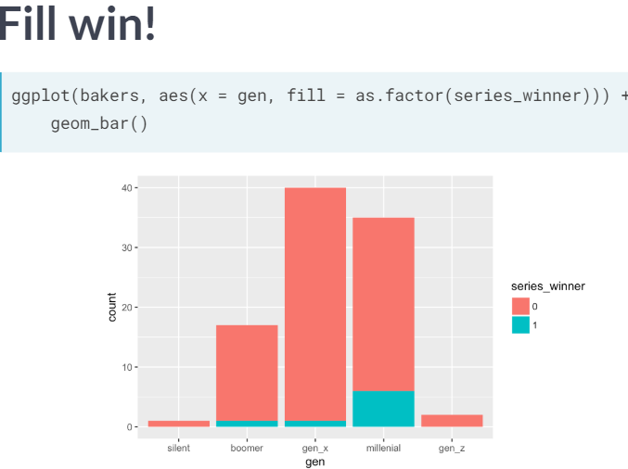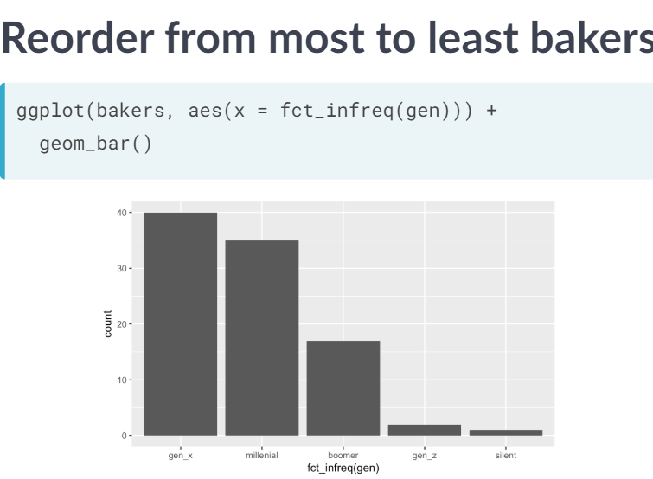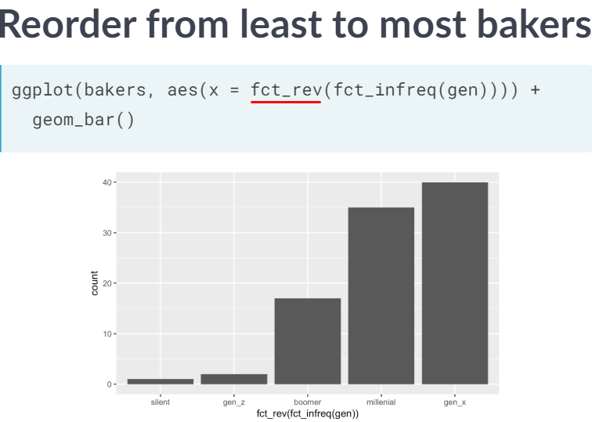pull

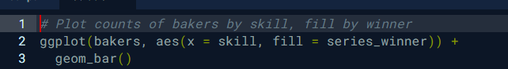

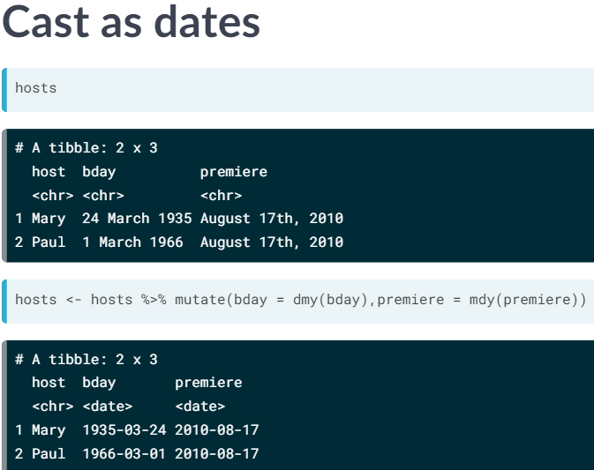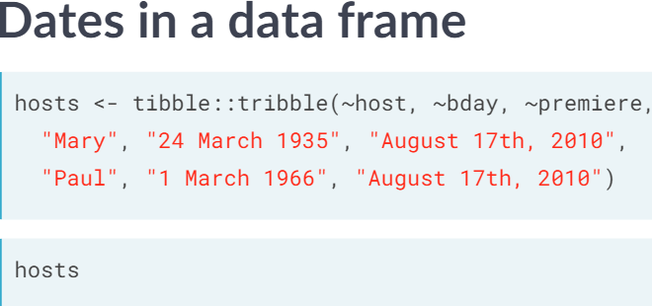Dates

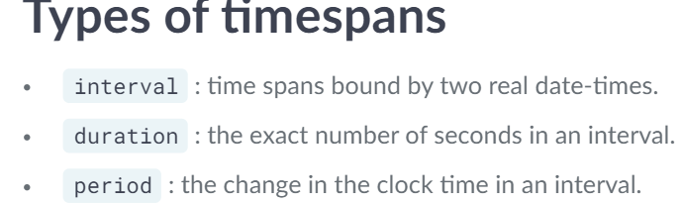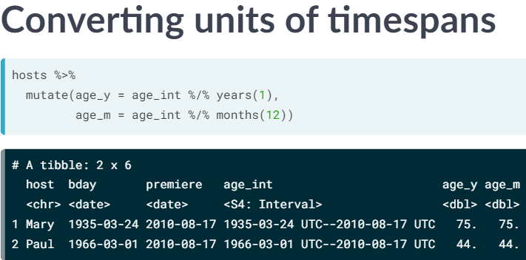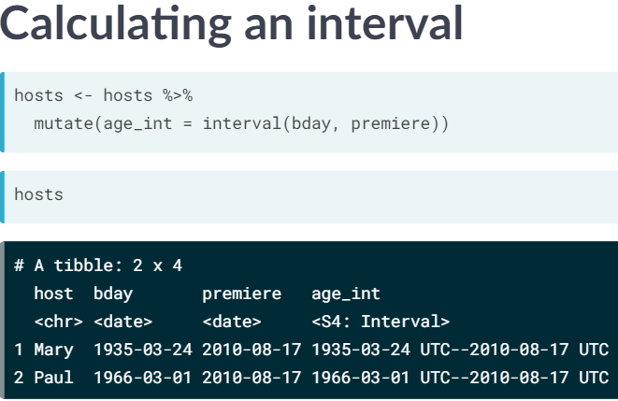Calculate difference between two days – lubridate is the library

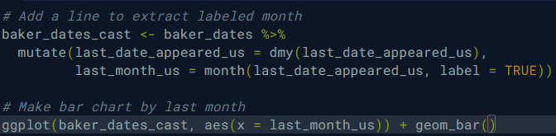Month()

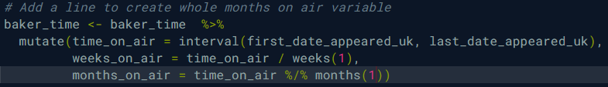

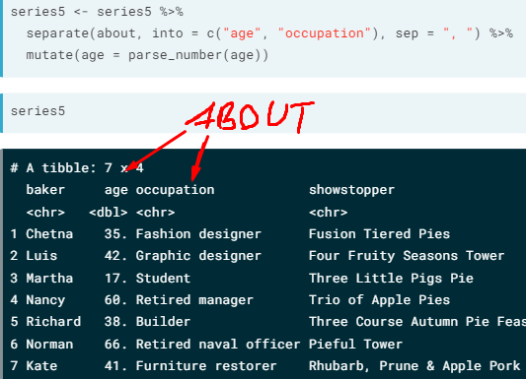String/ Separate

You can also use mutate(ear = str_to_upper(ear))

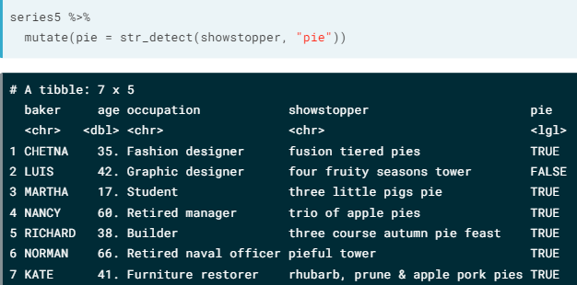To make everything upper/lower case

You can use str_detect

To check where is a word and always return logical . str_trim(ear) to remove whitespace if have “”

There is also str_replace(showstopper, “pie”, “cake”) and str_remove()

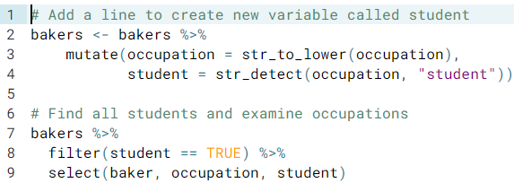

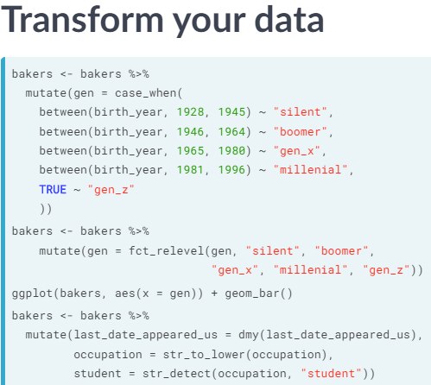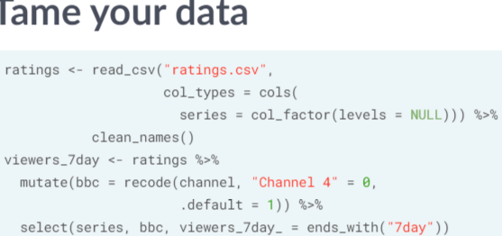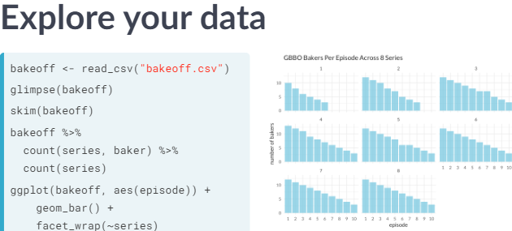  
Summary:

Data Visualisation with ggplot 2

Fine-tune scatter

##### Str() - Compactly Display The Structure Of An Arbitrary R Object

##### Grammatical Elements

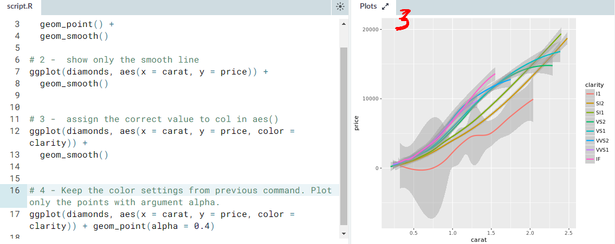Geom_smooth() – draws smooth lines over points



Base package – plot()

Abline() – adds straight line through current plot

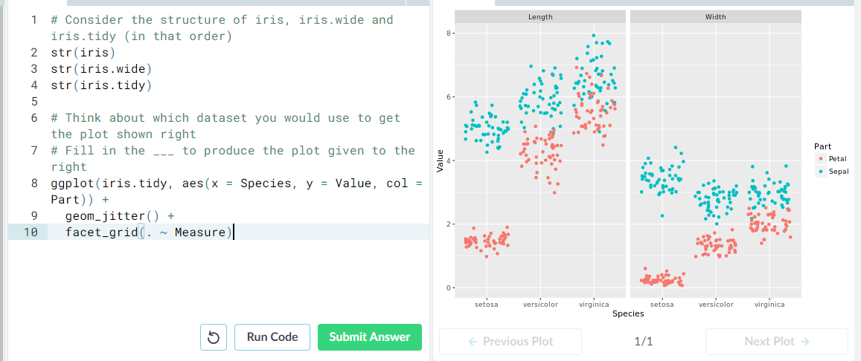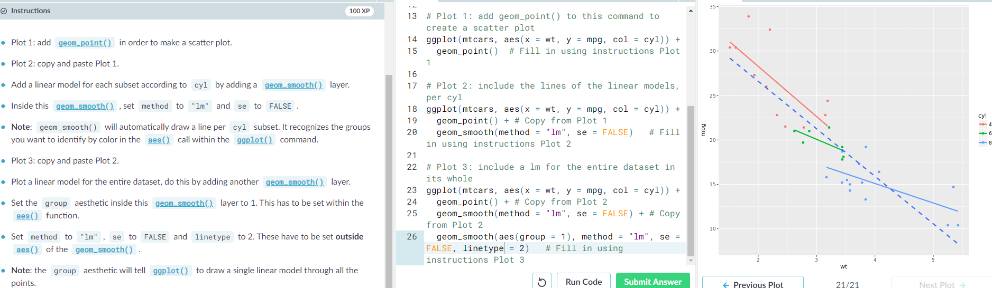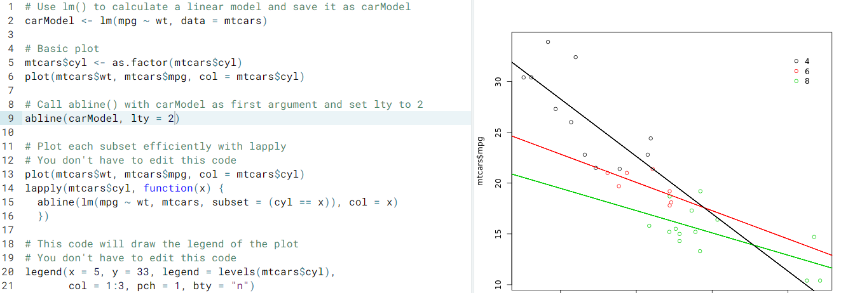

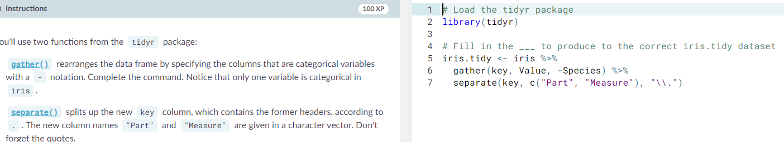

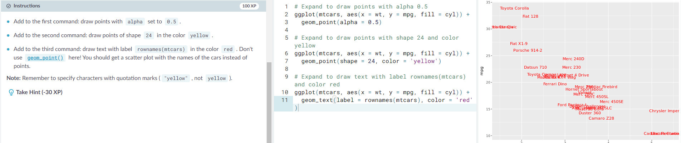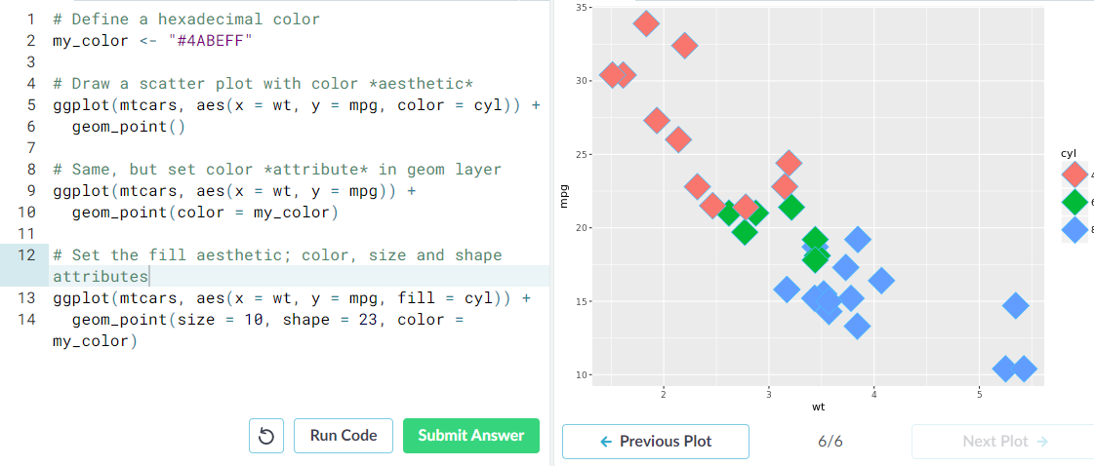Aesthethics

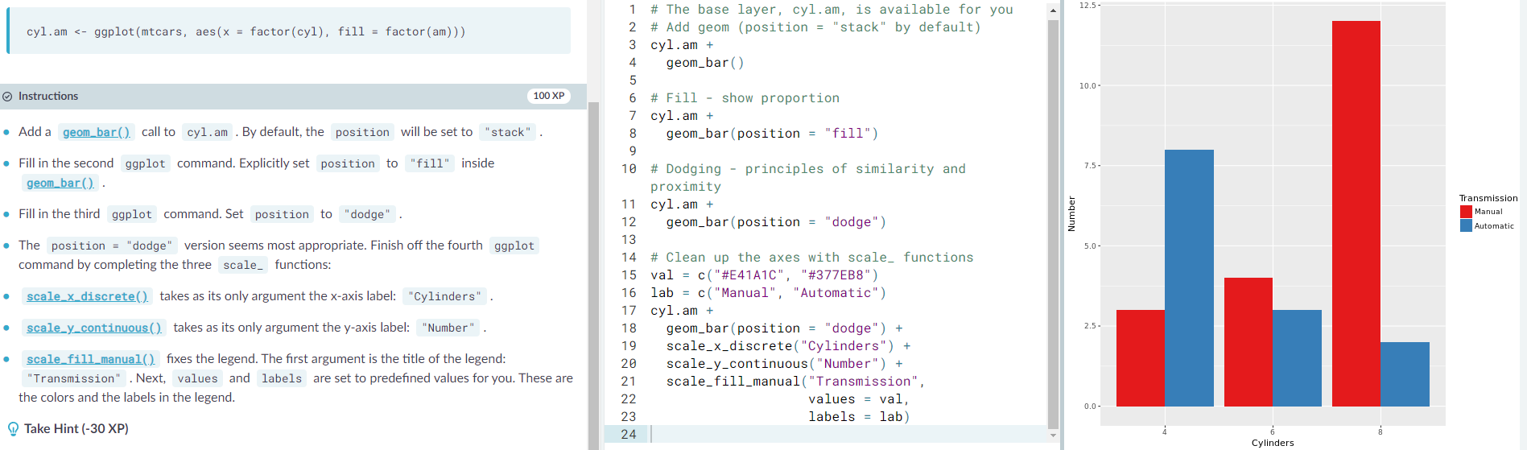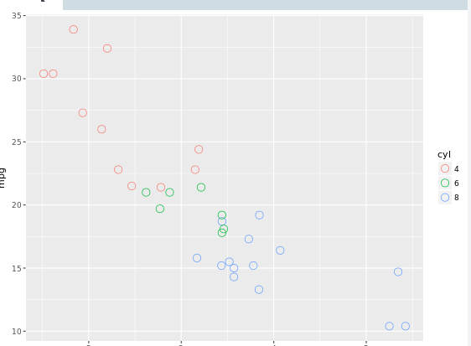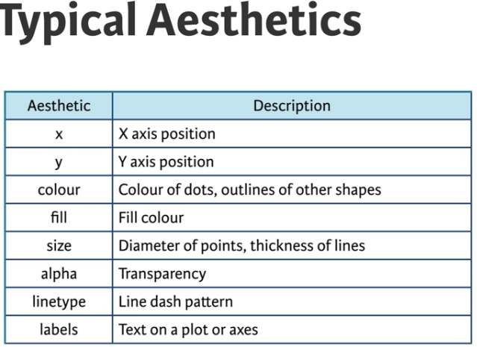Scales

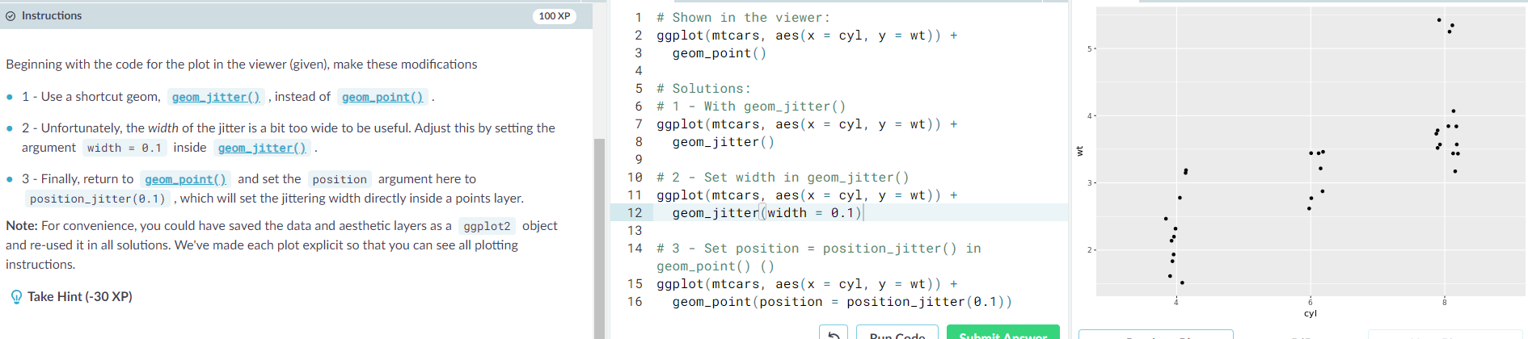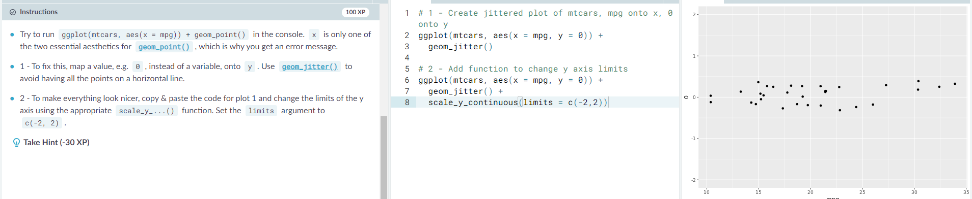Axis limits, continuous // position_jitter // dodge

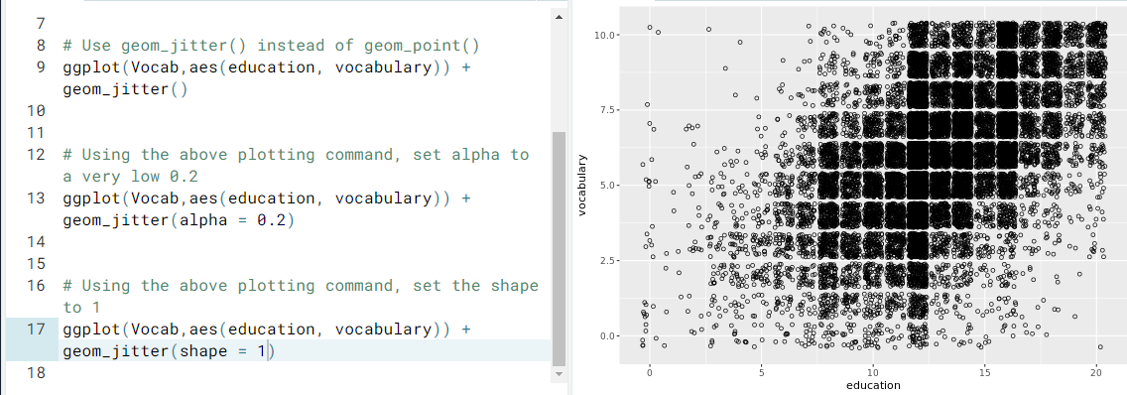

Histogram / binwidth

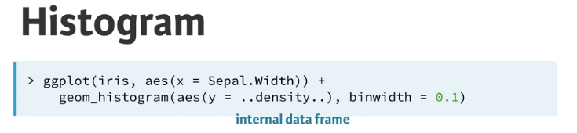

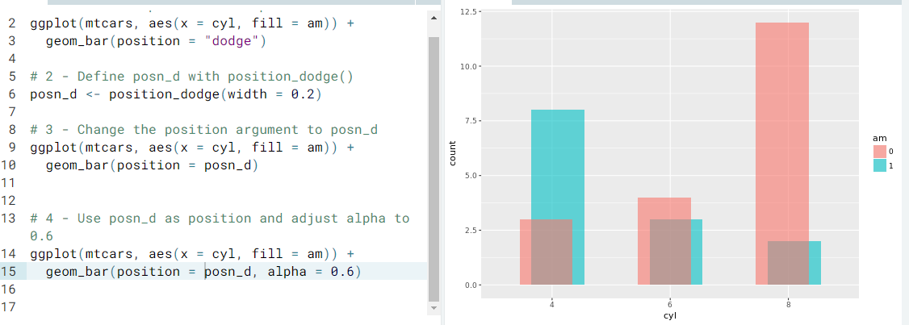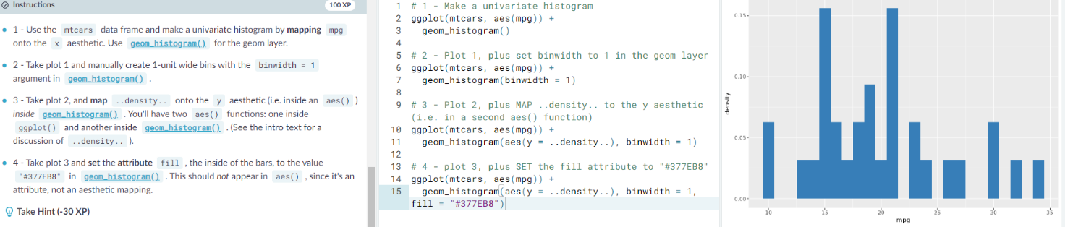The ..density.. tells that the data is from the internal data frame

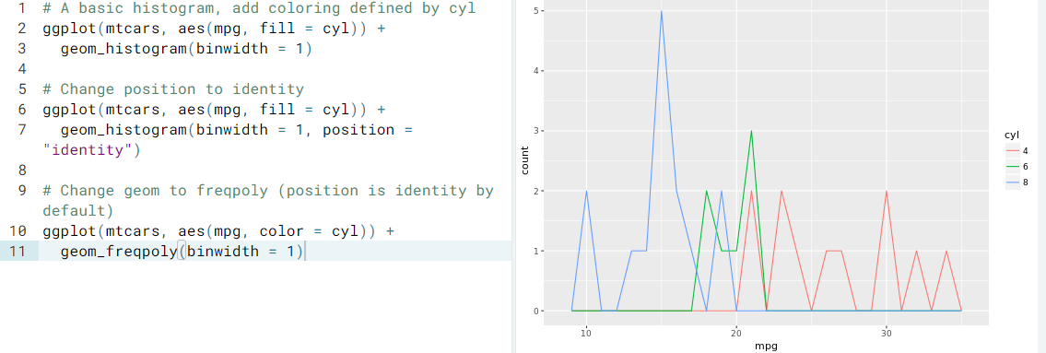

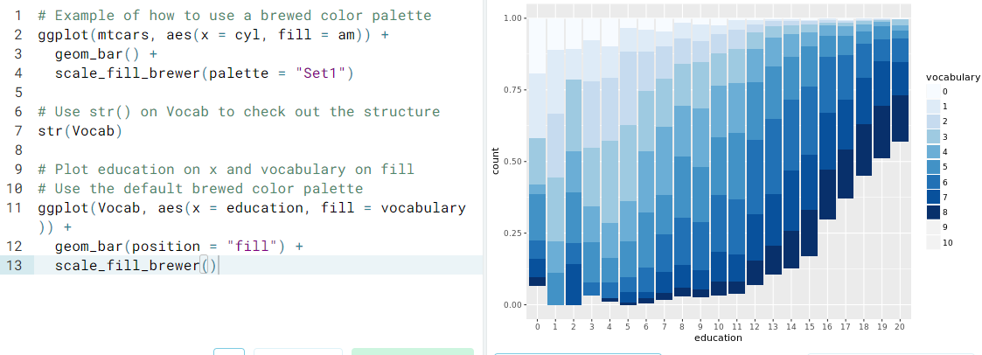

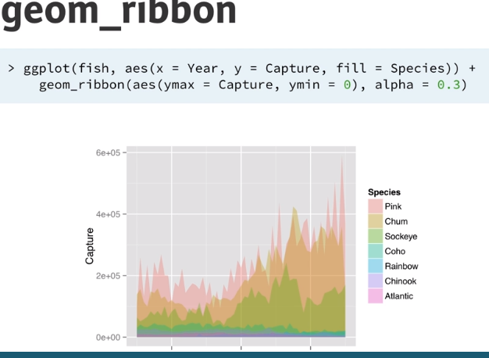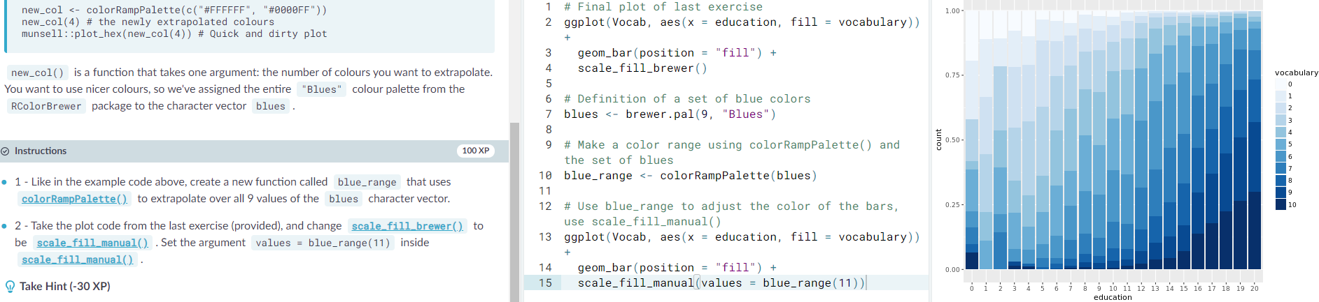

Geom_rect()

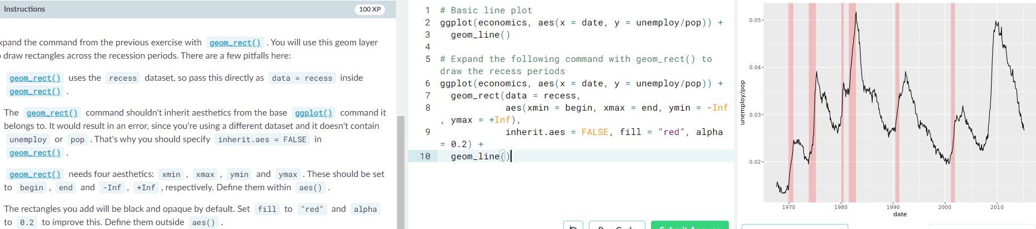

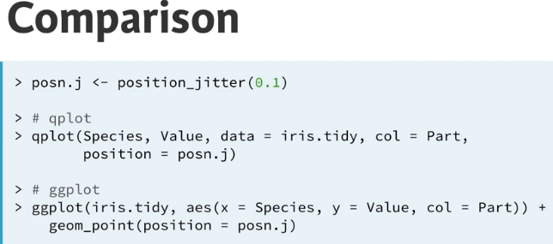Qplot()

